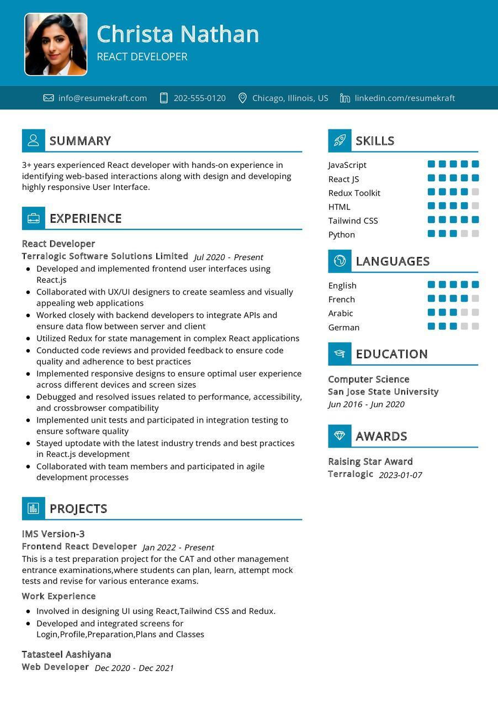
Christa Nathan
REACT DEVELOPER
info@resumekraft.com
202-555-0120
Chicago, Illinois, US in linkedin.com/resumekraft
SUMMARY
3+ years experienced React developer with hands-on experience in identifying web-based interactions along with design and developing highly responsive User Interface.
EXPERIENCE
React Developer
Terralogic Software Solutions Limited Jul 2020 - Present
SKILLS
JavaScript
React JS Redux Toolkit
HTML
Tailwind CSS
Python
LANGUAGES
• Developed and implemented frontend user interfaces using React.js
English
Collaborated with UX/UI designers to create seamless and visually appealing web applications
French
• Worked closely with backend developers to integrate APIs and ensure data flow between server and client
Arabic
Utilized Redux for state management in complex React applications
• Conducted code reviews and provided feedback to ensure code quality and adherence to best practices
• Implemented responsive designs to ensure optimal user experience across different devices and screen sizes
• Debugged and resolved issues related to performance, accessibility, and crossbrowser compatibility
• Implemented unit tests and participated in integration testing to ensure software quality
• Stayed uptodate with the latest industry trends and best practices in React.js development
• Collaborated with team members and participated in agile development processes
PROJECTS
IMS Version-3
Frontend React Developer Jan 2022 - Present
This is a test preparation project for the CAT and other management entrance examinations, where students can plan, learn, attempt mock tests and revise for various enterance exams.
Work Experience
• Involved in designing UI using React,Tailwind CSS and Redux.
• Developed and integrated screens for
Login, Profile, Preparation, Plans and Classes
Tatasteel Aashiyana
Web Developer Dec 2020 - Dec 2021
German
EDUCATION
Computer Science
San Jose State University Jun 2016-Jun 2020
→ AWARDS
Raising Star Award Terralogic 2023-01-07

